

EARLY HUMANS I & II

I Vocabulary

Stone age

Palaeolithic

Mesolithic

Neolithic

Hunter gatherer

Sickles

Flint

Pressure flaking

Stone on stone

Bhimbetka

Resin

Ochre

Pit house

Pottery

II KWL CHART

III Concept map

IV. Answer the following

**1. Define the following**

**a. Hunter-gatherers.**

* + Hunter-gatherers were early humans who survived by hunting wild animals and gathering edible plants, moving from place to place in search of food, water, and shelter.

# b. Stone Age.

* + The Stone Age is a prehistoric period when humans primarily used stone tools for survival, divided into three phases: Palaeolithic, Mesolithic, and Neolithic.

# 2.Case-Based Question

**Case Study**: Imagine you are an archaeologist excavating a site where early humans lived 12,000 years ago. You find stone tools, animal bones, and cave paintings. Based on this evidence, answer the following question.

**Question**: What does the discovery of cave paintings at this site suggest about early humans?

**Answer**: They expressed their lives and surroundings through art.

**Explanation**: Cave paintings, like those at Bhimbetka, show early humans depicted hunting, animals, and community activities, indicating they used art to express their thoughts, feelings, and daily life.

3. **Explain the significance of cave paintings like those found at Bhimbetka. What do they tell us about the lives of early humans?**

**Answer**: Cave paintings, such as those at Bhimbetka in Madhya Pradesh, are significant as they provide a glimpse into the lives, thoughts, and culture of early humans. These paintings, created using natural colors like ochre and charcoal, depict scenes of hunting, dancing, animals, and community activities. They suggest that early humans were skilled observers, capable of expressing their experiences through art. The paintings show cooperative hunting, indicating teamwork, and portray animals like bison and deer, reflecting their dependence on hunting. Some paintings may have had ritualistic or spiritual significance, suggesting early forms of belief systems. The Bhimbetka paintings, dating back thousands of years, are archaeological evidence of early human creativity and their ability to communicate through visual storytelling.

**4. Differentiate**

**A.Palaeolithic and Mesolithic periods.**

**Palaeolithic Period**:

* Time: Early times to about 10,000 BC.
* Tools: Crude, unpolished stone tools like hand axes and choppers.
* Lifestyle: Nomadic hunter-gatherers, no permanent settlements.

# Mesolithic Period:

* Time: 10,000 BC to 8,000 BC.
* Tools: Smaller, sharper tools like microliths, often attached to wooden handles.
* Lifestyle: Semi-nomadic, beginning to settle near water bodies.

**B. Early Humans and Modern Humans**

**Early Humans:**

1. **Physical Appearance:**
   * Early humans, like Homo habilis and Homo erectus, had smaller brains, more robust bodies, and more pronounced brow ridges. They had features more similar to apes.
2. **Tools and Technology:**
   * Early humans used simple stone tools and had basic tool-making techniques. Their tools included hand axes, scrapers, and simple cutting tools.
3. **Lifestyle:**
   * Early humans were primarily hunters and gatherers. They moved frequently in search of food and had no permanent homes.
4. **Communication:**
   * Early humans had limited forms of communication, likely consisting of simple sounds, gestures, and possibly early forms of language.

**Modern Humans:**

1. **Physical Appearance:**
   * Modern humans have larger brains, more slender bodies, and less pronounced brow ridges. We have a more refined facial structure and straight posture.
2. **Tools and Technology:**
   * Modern humans use advanced technology, including computers, smartphones, and machinery.
3. **Lifestyle:**
   * Modern humans have diverse lifestyles. We live in permanent homes, cities, and use complex transportation systems.
4. **Communication:**
   * Modern humans use complex languages, both spoken and written, and have developed extensive forms of communication, including the internet, social media, and books.

# 5.Picture-Based Question

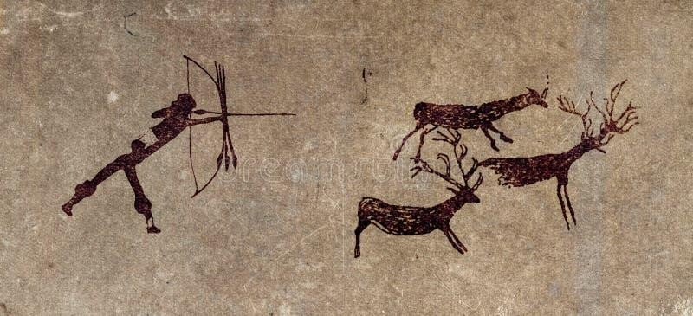

**Question**: Study the image of a cave painting from Bhimbetka showing a group of people hunting a bison. What does this painting tell us about the lifestyle of early humans? (write own answer)

**Sample Answer**: The cave painting suggests that early humans were skilled hunters who worked in groups to hunt large animals like bison. It indicates a cooperative lifestyle where hunting was a key activity for survival. The painting also shows their ability to observe and depict their environment, reflecting their artistic skills and recreational activities.

# GK Corner

1. **What were the main activities of early humans?**
   * Early humans hunted animals, gathered plants, made stone tools, skinned animals, and painted on cave walls.

# How did early humans use fire?

* + Fire was used for warmth, light, cooking food, and scaring away wild animals.

# Name the three periods of the Stone Age.

* + Palaeolithic (Old Stone Age), Mesolithic (Middle Stone Age), Neolithic (New Stone Age).